**Periodic Timer Trigger**

**Summary:** This document will explain you how to use Periodic Timer Trigger.

As we know Stock Prices are changing after every seconds/minute. So, we have added the Periodic Time Trigger in our Web Automation for extracting stock prices from LSE Website.

This automation will update the stock prices of each company.

The user creates an excel sheet with desired company codes and respective price columns.

**LSE URL**: <https://www.londonstockexchange.com/prices-and-markets/markets/prices.htm>

**Step 1:** Right click on Zap icon at bottom right corner of your window and select **Task Editor.**

**Step 2:** Open **StockPrices.zappy**

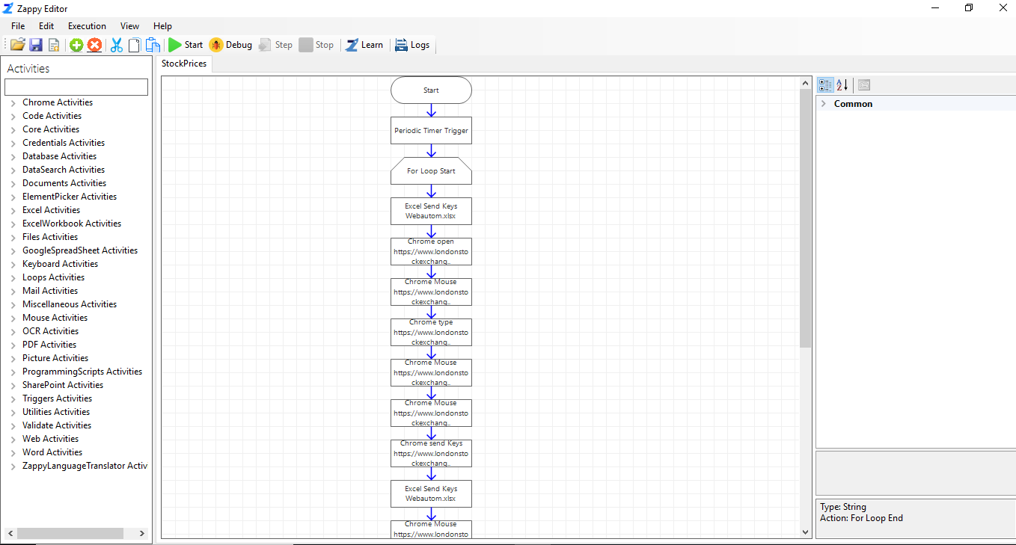

**Step 3:** Click on **Periodic Time Trigger** and set the properties.

**DueTimeInSeconds –** Set time in Seconds.

Set time for performing the task.

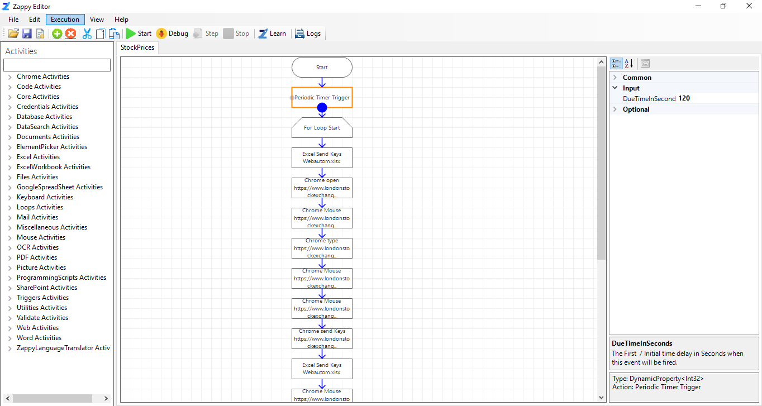

We can add Periodic Timer Trigger to any other automation which we want to run often.

**Step 4:** Click on **Start** button to register the trigger.

You will see the message “**Successfully Registered Active Trigger**” from Zap.

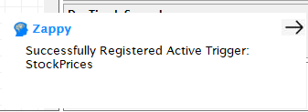

**After every 120 seconds Periodic Timer Trigger hit and extract the stock prices from LSE website and store it in Excel.**

You will see “**Successfully Executed Task**” message from Zap whenever trigger will fire.

